**Competitive Pokemon**

**DOCUMENT OUTLINE**

**Introduction**

This is the exploration of a pokemon dataset containing 802 pokemon (Generations 1-7) and their many attributes. We chose this dataset as we feel most passionate about pokemon over other topics. We each grew up playing pokemon and therefore already have insight into the inner workings of the pokemon universe. We also felt that this dataset would challenge us adequately as we have a high drive to discover what's within this dataset. It would also serve to challenge us because it has various missing values and odd portions that make for an obstacle in our research.

**Group Members:**

Riley Dunn (git-it-dunn)

Zachariah Friesen (sadtomat1999)

Jacob Turner (J6k3School)

Frank Delgado (FatDeacon)

**Contributions:**

Each team member worked on various parts of both the code and the written portions. We had five questions with multiple parts per question resulting in various graphs and information to work with. There is an extensive amount of writing done both for a document and read me file that was written by all members of the group. Overall, all members had equal parts in each section of the project.

**Questions:**

1. **How does type correlate to the defence stat a Pokémon has?**
2. **Does the weight of a Pokémon affect its attacking stats? If so, what is the correlation between the two stats?**
3. **What is the best offensive Pokémon (fast and hits hard)?**
4. **How does type correlate to how much attack a Pokémon has?**
5. **What is the “best” Pokémon based on stats and typing alone?**

**Description of Data**

The data set we decided to work on is a collection of 802 pokemon from the first seven generations of pokemon. It includes information about these pokemon that allow us to ask questions to better our knowledge of the pokemon world. Information on these pokemon like weight, attack damage, defence, type weakness and strengths are included. Information was collected from this website: <https://serebii.net/>. The website has all the information of all pokemon and the dataset we used is a compilation of this data. Our dataset came from this website: <https://www.kaggle.com/rounakbanik/pokemon> .

**Analysis Of The Data**

Through our analysis, we aimed to answer five of our previous questions. These questions attempt to find the best pokemon given the situation. The dataset has faults that need to be worked through. For example: pokemon can sometimes have two types. This means that some pokemon will be without a type 2 and will leave a null value. The same can be said about the weight of some pokemon where they lack a weight. Another fault in the dataset is that pokemon number 63 is missing a name. This can cause some programs and analysis

**Exploratory Data Analysis  
Question 1: How does type correlate to the defence stat a Pokémon has?**

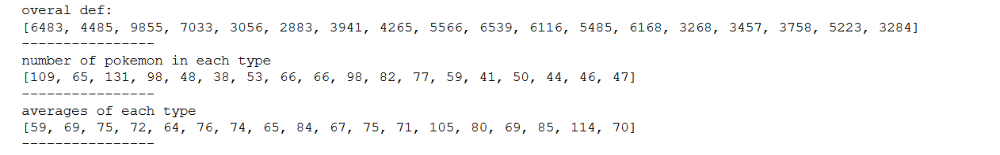

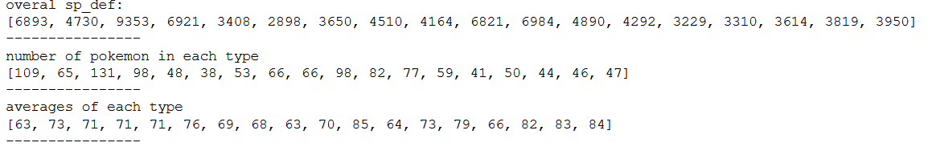

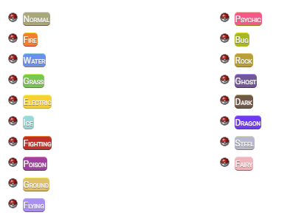

Image 1 first shows the overall defense stat of each pokemon type in image 3, starting from top left (normal to flying) to bottom right (psychic to fairy), which means that the indexes are ordered in the same way as the typings. For example, the normal type (first) has an overall defense of 6483, and the fairy type (last) has an overall defense stat of 3284. Image 2 does the same but with overall special defense. The second section of the first two pictures shows the number of pokemon that have the corresponding specific typing. Finally, the last section shows the defense stat average (picture 1) and the special defense stat average (picture 2) for each typing.

We can see that even though water-type pokemon have the overall higher defense stat, the only reason why is because of the sheer amount of pokemon in that category. After averaging the overall defense and the number of pokemon of each type, we can conclude that steel-type pokemon have the highest average defense stats in the game. Steel-type pokemon also have the third highest average special defense in the game, which makes sense because steel-type pokemon were introduced to the games to balance out the overpowered normal and psychic types from previous generations. We can also conclude that psychic type pokemon have the highest special defense in the game, which also makes sense because they are a type that specifically revolve around the special attacking moves and abilities within the games.

In conclusion, we can see that the typing of a pokemon does relate to it’s defense stat in a way an average pokemon player would expect.

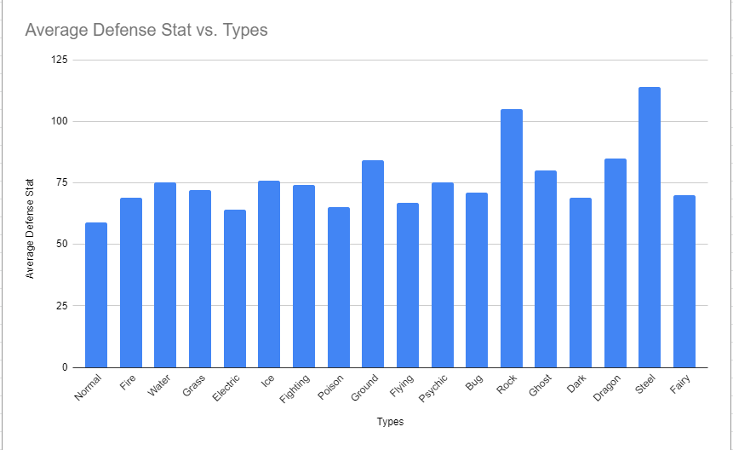

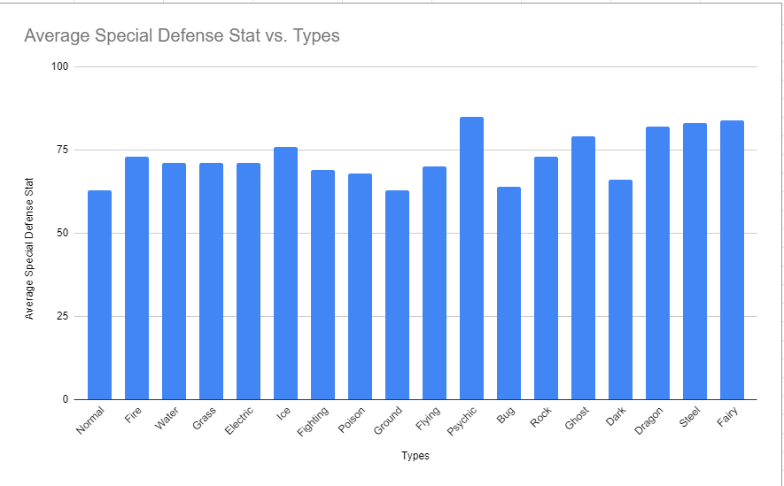

**Question 2: Does the weight of a Pokémon affect its attacking stats? If so, what is the correlation between the two stats?**

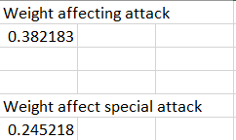

As the correlation is lower than 0.5 in both cases, there is no apparent positive correlation between the attack and speed, or special attack and speed. However, the reason the correlation is not zero is because the weight of pokemon usually increases as they evolve. When pokemon evolve, their stats increase, which leads to the very slight correlation the statistic represents. Special attack on the other hand has an even lower correlation because pokemon who have high special attacks don’t tend to be large creatures. In a lore perspective, special attack is derived from things other than physical strength. Special attacks consist of things like shooting a beam of energy and not hitting the other pokemon with a rock, things that do not correlate with physical strength. For this reason, pokemon who have high special attacks usually do not evolve to become bigger.

**Question 3: What is the best offensive Pokémon (fast and hits hard)?**

As shown in the output, Aerodactyl or in this case, Mega-Aerodactyl is the best offensive pokemon as it has the highest total between the attack and speed stats. This was found by filtering through the data set to find all the pokemon with the rock-type as part of their typings since rock-type has the best ratio of most effective against to not very effective against. The ratio was 4:3 which means that the rock-type is super effective against 4 typings while only being not very effective against 3 typings, making rock-type the best ratio of all types. Next, the attack and speed stats of all the rock-type pokemon had to be added together to find the highest overall value. This led to us finding that Mega-Aerodactyl had the highest overall speed + attack stat of all rock-type pokemon with a whopping 285.

**Question 4: How does type correlate to how much attack a Pokémon has?**

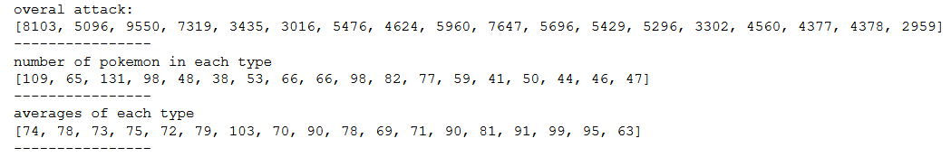



Just like in the first question, image 1 first shows the overall defense stat of each pokemon type in image 2, starting from top left (normal to flying) to bottom right (psychic to fairy). The index order is also the same as question 1. The overall attack stats show more of a correlation with the number of pokemon of each type, so it’s not a great way to gauge exactly how type correlates with attack. The third section however shows the average attack stat you would find in pokemon with said typing. The graph shown below puts this section into a more visual perspective.

With these averages put into perspective, it’s much easier to exactly how typing correlates with the attack stat. As one would assume, fighting-type pokemon have the highest average attack stat out of any typing. While psychic pokemon, who mainly focus on special attack, have the lowest average attack stat out of any typing. Dragon-type pokemon come in second place and steel-type pokemon come in at a close third. Just like how one would imagine a dragon or something made out of steel to hit hard, these values reflect that well.

In conclusion, typing does correlate with a pokemon’s attack stat in a way that the average pokemon player could guess.

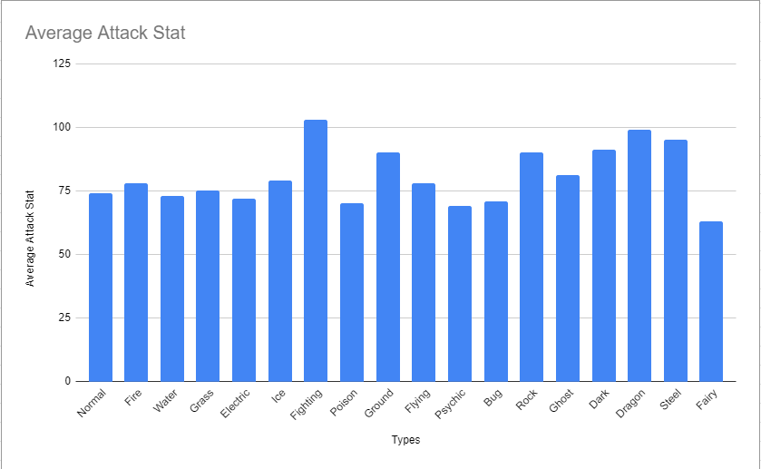

**Question 5: What is the “best” Pokémon based on stats and typing alone?**

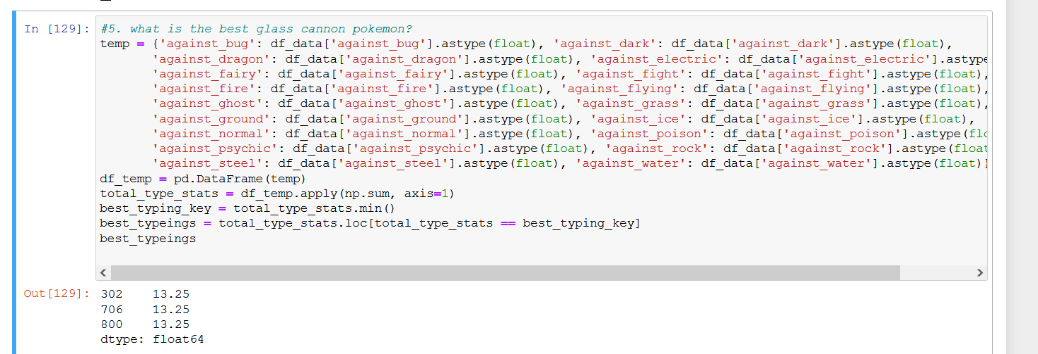

The above image shows the code used to find the three “best” pokemon by just typing alone. An extra dataset was made and the apply function was used to produce a value that directly correlates with the resistances an individual pokemon has. The lower the value is, the more resistances that specific pokemon has and vice versa. The values in the hundreds produced at the bottom show the index value (or PokeDex value) of said pokemon with just a slight variance as some indexes were used as labels. For example number 302, the pokemon Mawile, should actually be 303 as an index is used for a title. The three values produced are the best pokemon for total overall resistances, 302 is Mawile, 706 is Klefki, and 800 is Magearna. All three of these pokemon have the Steel/Fairy typing, which is the best defensive combination in the game by far. Afterall, the “best” pokemon has to have the least amount of weaknesses. All that was left now is to compare these three pokemon and figure out which one has the highest overall stats. Using this strategy, Magearna (800) is the “best” pokemon between those three by a longshot, which makes sense since Magearna is a mythical pokemon while the other two are not. Obviously if you knew about competitive pokemon, this result is not

In conclusion, the “best” pokemon based on stats and typing alone is Magearna (800).

**Potential Data Science**

Working with this dataset we found that the more questions we answered, the more questions were made. We realize that each of our questions lead to the optimization of the game through finding the best and worst Pokémon. If we wanted to continue with this project and go further, we would want to find enough information on all the Pokémon that would allow us to make an AI. This AI would be able to fully optimize gameplay by finding the best Pokémon to then build a team. Some specific details are below.

We found the greatest glass cannon Pokémon but as we worked, we wondered what the worst glass cannon Pokémon was. We asked if it would be the worst Pokémon or would it have anything which will make it worth using, for example its type makes it worth using on your team. If we went further with this part, we want to find how some Pokémon make up for bad stats. Some may be big and slow but have amazing attack damage. Others might be fast but have very low attack. Some Pokémon will seem bad but may have some saving grace factor that is worth exploring.

Finding out how the type of the Pokémon and attack correlate did not generate many more questions. We found that fighting-type pokemon were the strongest and psychic-type pokemon were the weakest physically. One thing that might be able to be investigated is if certain types of Pokémon are better than others in certain areas. Again, some Pokémon might be better with speed and others attack. Finding which type is better at what can tell us how to use each one in some battles.

We also asked a similar question that related to type and a certain attribute where we asked how type and defence relate to one another. If we were to explore this more with other things like attack and certain strengths against different types, we would find what type is best in a given situation. Imagine your team has a big weakness to fire types and you need a counter and the best Pokémon to defend against it. There are needs to be met in each team and this data set can help you find which Pokémon can fill those needs.

**Conclusion**

Though this data set will give us almost an infinite amount of questions about each pokemon, this of which in competitive pokemon could be a huge strong suit for the person with it in making the best team. A couple of those questions we asked and found the answers, first being finding which pokemon type has the greatest attack stat of all of pokemon through comparing the attack stats of each pokemon and relating them with the other pokemon of the same typing. Through this method we could find that fighting type pokemon tend to have the highest attack stat of all pokemon types.With this information you can find that if you need a hard hitting pokemon then looking into the fighting type pokemon could be your best option. Through a similar method you can find the type of pokemon with the greatest defence or special defence of all pokemon. So with this if you need a strong physically defensive pokemon on your team, pokemon of the steel type would be great for you. For the specially defensive you can find that physic pokemon have great special defence but not so great physical defence so you can take that information and choose what is best for your team and what you need. In pokemon when building teams you normally find one pokemon and build your team around that one pokemon taking its weaknesses and having other pokemon to then help out to take care of those weaknesses so we wanted to find the best pokemon to have the least amount of those weaknesses so we found the best type combination being steel and fairy then found the best pokemon with that type combination being Magearna (800) having the best stats of that type. And if you need a strong fast offensive pokemon we looked through the types that had the most types it was effective against and found the pokemon with the best speed and attack stats and this led us to say that Aerodactyl or in this case, Mega-Aerodactyl fits the most into this role.